|  |
| --- |
|  |
|  |

These tasks will show you how to save time editing your slides in PowerPoint whilst maintaining a professional appearance.  
  
***Note:*** *Some of these functions cannot be set up in the free online version of PowerPoint.*

**Appendix 5 – PowerPoint Patterns**

A5

The Interactive

Kiosk Project



***Aim:*** *To learn how to use slide masters and other time-saving tools in PowerPoint.*

#### Task 1 – Slide Masters in PowerPoint

In PowerPoint, *Slide Masters* allow you to control the design of all the other slides in your presentation. If you make changes to a slide master, then these changes will automatically be made to the other slides. This cuts down the amount of editing required to keep your presentation looking professional.

The *slide masters* can be used to change the fonts, effects, animations, shapes, pictures and colours on other slides. This can save a lot of time if your presentation is large.

There are two layers of slide master as mentioned below.

**Office Theme Slide Master** *This slide master generally applies to your whole presentation.*

**Layout Slide Masters** *Each different type of layout also has its own slide master. These can be edited in order to change all the slides that use that particular layout design.*

**Office Theme Slide Master**

**Title Slide Master**

**Slide 1  
(a *Title* slide)**

**Appearance of Slide 1, which is a *Title Slide***

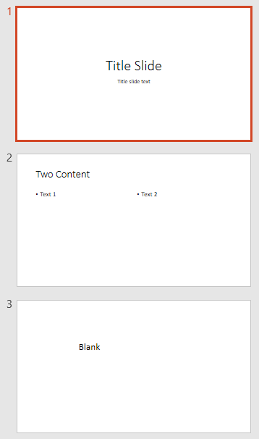

1. Open a new blank presentation and create three slides. The first will be a *Title slide* by default. Give the second slide the layout *Two Content* and the last slide the layout *Blank*.

1. Type some text in the first two slides but don’t format it. It doesn’t matter what this text says.
2. Insert a text box on the third slide (‘Insert / Text Box’) and enter some text.

|  |
| --- |
| **PowerPoint** **Patterns (page 2)** |

1. Click on ‘View / Slide Master’ and scroll up and down the slide masters in the pane on the left. Notice the (larger) *Office Theme Slide Master* at the top and then a slide master for each type of layout below. Hover your mouse over each one and check which are used in your slides.

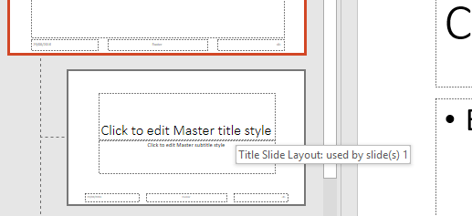

**Hover over the slide masters to see which slides are picking up the styles**



1. Click on the *Office Theme Slide* *Master* and change the font and colour of the text. Insert a coloured shape onto the screen. Notice how these changes are picked up by all the other slide masters.

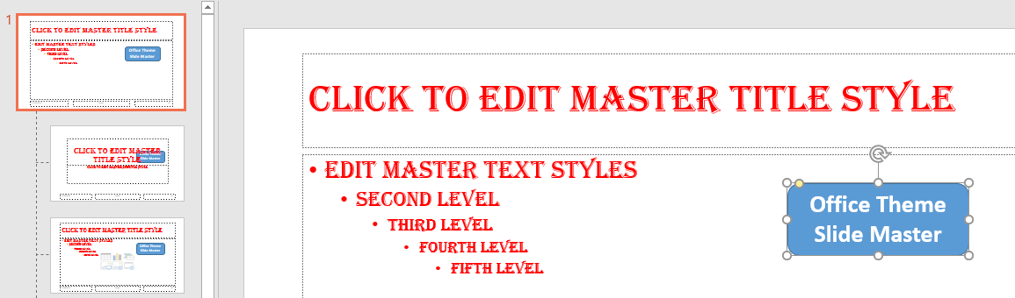

1. Click on ‘View / Normal’ to return to the editor and look at the effect of the changes on each slide. Notice that the text is reformatted in all the placeholders but not in the text box on third slide.
2. 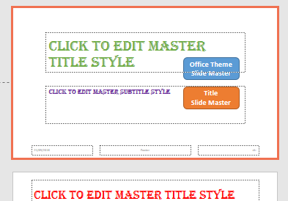Return to the slide master view and make some changes to the *Title Slide Layout*. Check that these only affect your title slide.

1. Experiment with the *Two Content* and *Blank* slide masters, checking the effect of each.   
     
   ***Note:***  *Things can look a bit tidier if you delete any unused slide masters. You might need them later on but you can always recreate them if this is the case.*

|  |
| --- |
| **PowerPoint** **Patterns (page 3)** |

#### Task 2 – PowerPoint Themes

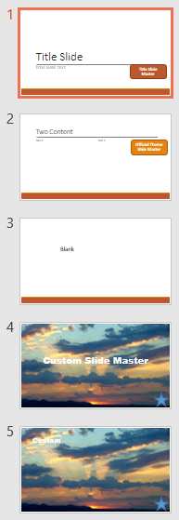You might find a theme in the *Design* tab that you like. Themes can save you time and effort by providing a professional finish at the click of the mouse.  
  
Once you’ve applied a theme, you can make the following changes:

* The theme objects can be edited in the *Office Theme Slide Master*. When you insert shapes or other objects, you will be given the choice of theme colours, although you may also select from the full colour palette using the *Fill* menus.

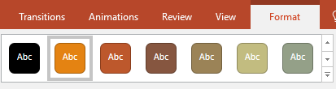

* You can change the theme background on any single slide. Right-click and select ‘Format Background’ or look under the *Design* tab.

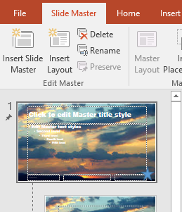

* You can apply a different theme to a set of pages by opening the slide master and clicking on ‘Insert Slide Master’. This set of slide masters can be edited in the same way as the first. You can then decide which theme is used on any page using the ‘Home / Layout’ menu.

#### Task 3 – Reusing Objects

For your kiosk interface, you might decide that there are objects that you would like to show on many slides but not all of them. An example might be buttons to restart, exit and get help.

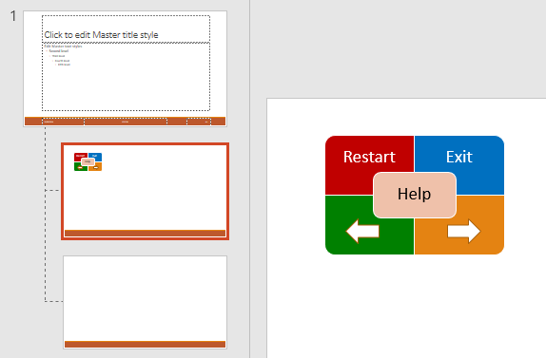In the example on the right, we have set up two new layouts in the slide master (‘Slide Master / Insert Layout’); one with buttons and one without. You can then select from these two layouts for all other screens in your kiosk interface.

Once you have assigned all slides to one of these two layouts, you can delete any unwanted layouts from the slide master.

Remember that if you want more options to choose from, you can insert more layouts or more slide masters.

Make sure that you are able to manipulate slide masters in any way that you might need for your kiosk interface.